TEAM:4

**4.CREATE A SOCIAL MEDIA POST**

**PROJECT DOCUMETATION:**

1. **WHAT IS GRAPHICDESING:**

**Graphic design is a form of visual communication consisting of illustrations, typography, and photography, which helps to communicate target audience visually. Using graphic design we can create communicative visual content like logos, brochures, visiting cards, posters, newsletters, banners, web templates, etc. Using graphic software’s like Photoshop, illustrator, and Canva*.***

**2.CANVA CERTIFICATE EDITING FOR PHOTO EDITAND CERTIFICATE:**

**Graphic design is canva use is media post new model desinging editing cate in canva project.**

CANVA EDITING KEY WORK:

1. Canva app opan is mobile phone is the canva project use in the canva.
2. Canva is new + ican is the canva.
3. “SEARCH” open is canva.
4. 2st Your Tittle is social midea post
5. Canva is my botton click on.
6. The canva is write page open on.
7. New opan is canva.
8. Search a4 (landscape) tamplates is canva.
9. Templates and styles (search) open.
10. Social media post all 727116 temples in the canva.
11. “Crete blank” click.
12. All the open media in canva app use.
13. Your new use on the canva.
14. Your style in the canva project on canva
15. Edit the document font change your name and tittle name typing use canva.
16. Canva change you font and font size and color and formet and spacing and effets and animate transparency change in the canva editing work.
17. Full size change in canva use replace and color and effects and filters adjust and crop and filp and animate and transparency and layers and info and more change your full size in the canva app on.
18. Elements change graphics click on.
19. The generate your own.
20. Open on the canva work.
21. Element change on the canva.
22. Color change your color in the canva.
23. Edit in Canva media save your on the canva app.
24. Save the image download ican click in canva.
25. PNG AND PDF save as
26. Save download settings.
27. Download click on canva.
28. Your etinding in canva image save in the gallery .
29. My mobile phone save in gallery.
30. Design content in a way that is useful for your followers.
31. Incorporate different types of designs in your content.
32. Balance individual content with your overall profile page.
33. Design themed content and templates. ...
34. Adjust your design based on analy.
35. Team my is post editing in canva .

SOCIAL MEDIA POST: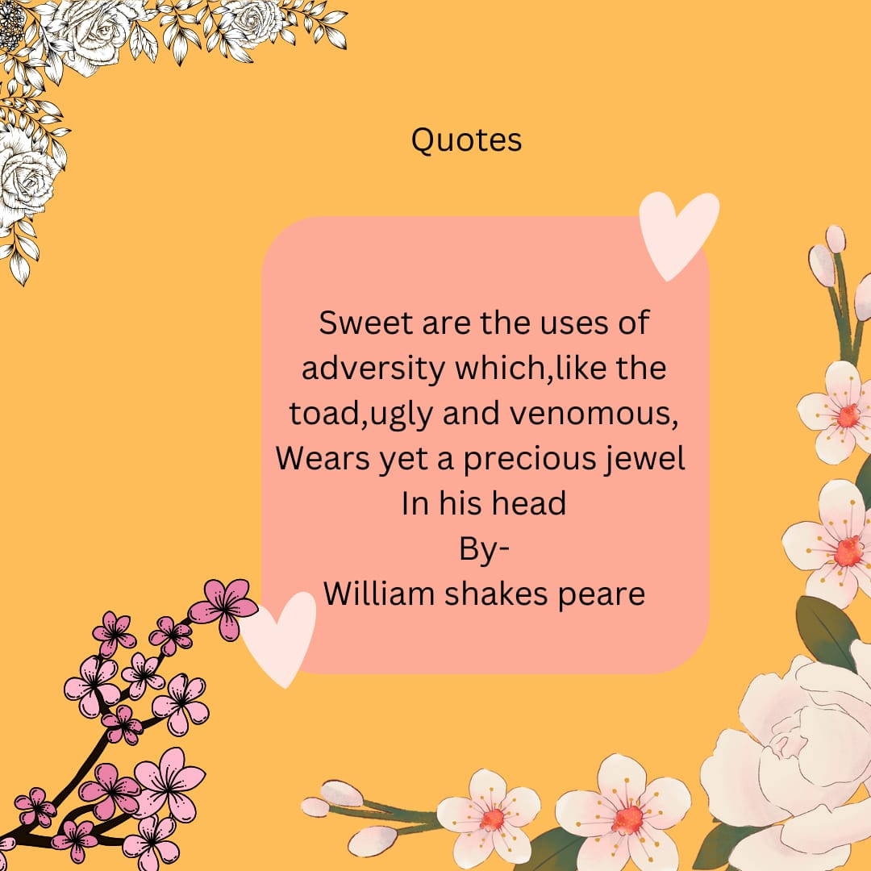 ----------------------------- THANK YOU ------------------------------------